Cointegration and ECM: USDCAD and EURGBP
Method 27 / Engle-Granger on log closes / one-lag ECM / Alpari D1 full available history

Study setup
Logical pair: PX=USDCAD , PY=EURGBP
Broker symbols: USDCAD_i , EURGBP_i
Snapshot: 2026-11-03_majors_alpari_D1
Timeframe: D1
Matched window: 1999-01-06 to 2026-11-02 (UTC bar dates)
Matched level count n: 7185
Dropped unfinished last bar dated 2026-11-03 UTC after a tick-volume check against the prior complete day.
ECM lags of deltas: 1
Complete matched rows (Excel): USDCAD-EURGBP_Coint_D1.xlsx
Complete matched rows (HTML table): USDCAD-EURGBP_Coint_D1_data.html

Method carried forward
Engle-Granger cointegration works on log price levels, not returns. For each unordered pair, PX is the left leg and PY the right leg. Step one: OLS ln(PY) = alpha + beta * ln(PX) + e. Step two: statsmodels Engle-Granger coint test on (ln(PY), ln(PX)). Error-correction: delta ln(PY)_t = c + kappa * e_{t-1} + lagged delta ln(PY) and delta ln(PX) (one lag each) + u_t. Headline is the Engle-Granger p-value (lower = stronger evidence of a stationary spread) with kappa and beta reported alongside. Same-sample Pearson r of log returns is a side check only. beta is not an automatic lot-size hedge. This is not a trading signal.

Results (headline)
alpha: -0.171099
beta: -0.336354
Engle-Granger t: -1.501586
Engle-Granger p: 0.760583
5% critical value: -3.336981
ECM kappa: -0.000780
kappa t-stat: -1.6257
ECM R^2: 0.001959
spread std: 0.119615
Pearson r (returns): -0.014622

Conclusion
Engle-Granger for PY=EURGBP on PX=USDCAD: beta=-0.3364, alpha=-0.1711, coint_t=-1.5016, p=0.7606 (5% crit=-3.3370). ECM kappa=-0.0008 (t=-1.63). Pearson r of returns = -0.0146. beta is not a lot-size hedge. Not a trading signal.

Charts
Daily closes

Engle-Granger residual spread
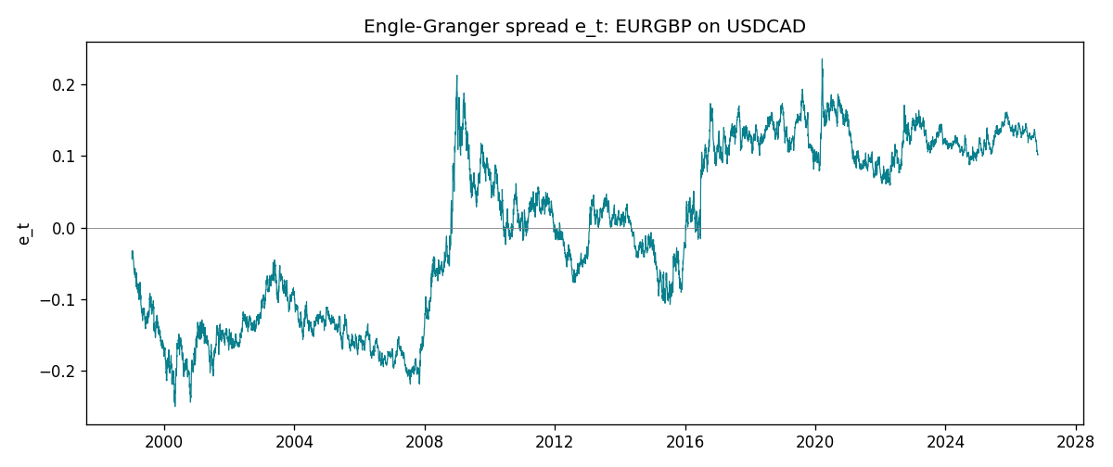
Daily log returns
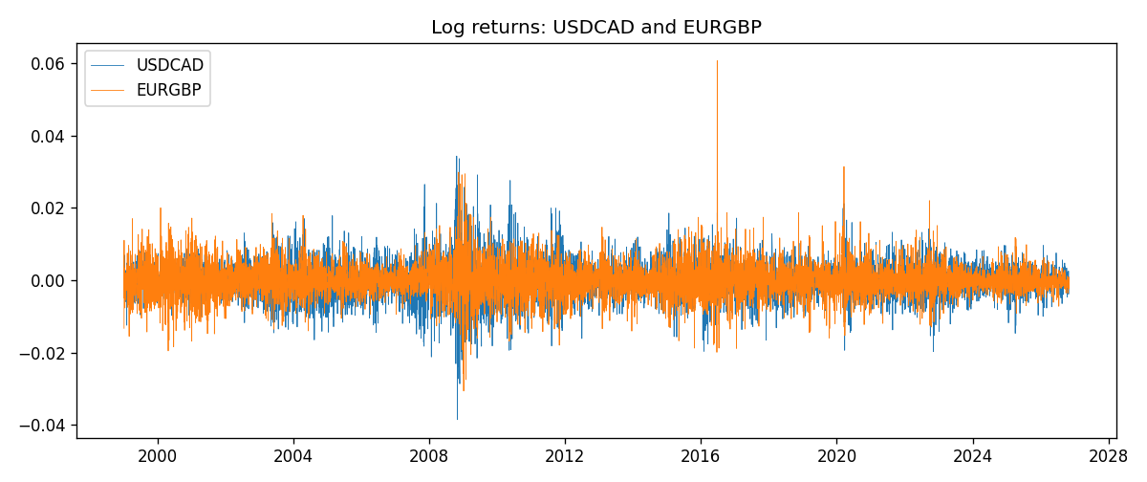

Data report
Matched rows are in the sibling Excel workbook named USDCAD-EURGBP_Coint_D1.xlsx. Embedding all rows as a Word table is impractical; this file holds column summaries and the first and last 15 matched rows.
Column summaries
column | count | mean | std | min | 25% | 50% | 75% | max
USDCAD_open | 7185 | 1.2666594 | 0.16886861 | 0.9168 | 1.1183 | 1.29841 | 1.37203 | 1.6183
EURGBP_open | 7185 | 0.78693389 | 0.09666561 | 0.5734 | 0.6876 | 0.83387 | 0.86521 | 0.9769
USDCAD_high | 7185 | 1.2715589 | 0.16882635 | 0.9336 | 1.1227 | 1.30381 | 1.3764 | 1.619
EURGBP_high | 7185 | 0.79000929 | 0.09704455 | 0.5789 | 0.6896 | 0.8369 | 0.8681 | 0.9799
USDCAD_low | 7185 | 1.2621046 | 0.16891061 | 0.9056 | 1.11396 | 1.29347 | 1.36776 | 1.6102
EURGBP_low | 7185 | 0.78423344 | 0.09648411 | 0.5682 | 0.6855 | 0.83166 | 0.86287 | 0.9661
USDCAD_close | 7185 | 1.2666836 | 0.16885076 | 0.916 | 1.118 | 1.29833 | 1.3723 | 1.6137
EURGBP_close | 7185 | 0.78697576 | 0.09666885 | 0.5735 | 0.6878 | 0.83391 | 0.86533 | 0.977
USDCAD_tick_volume | 7185 | 81049.359 | 147325.09 | 37 | 5563 | 40946 | 71633 | 1410818
EURGBP_tick_volume | 7185 | 87109.869 | 145486.28 | 154 | 6553 | 44326 | 81375 | 1424684
USDCAD_spread | 7185 | 23.430202 | 18.259258 | 0 | 9 | 17 | 40 | 60
EURGBP_spread | 7185 | 21.335421 | 19.123862 | 0 | 4 | 13 | 40 | 50
USDCAD_real_volume | 7185 | 1.8384377e+10 | 9.670755e+10 | 0 | 0 | 0 | 0 | 2.5751613e+12
EURGBP_real_volume | 7185 | 2.7864528e+10 | 1.3519652e+11 | 0 | 0 | 0 | 0 | 3.5726265e+12
USDCAD_log_price | 7185 | 0.22725029 | 0.13642556 | -0.08773891 | 0.11154137 | 0.26107882 | 0.31648816 | 0.47852968
EURGBP_log_price | 7185 | -0.24753598 | 0.12811447 | -0.55599734 | -0.37425718 | -0.1816298 | -0.14464434 | -0.02326863
USDCAD_log_return | 7185 | -8.08e-06 | 0.00514591 | -0.03859748 | -0.00283484 | 5.597e-05 | 0.00272835 | 0.03436319
EURGBP_log_return | 7185 | 1.874e-05 | 0.00486681 | -0.03067367 | -0.00262366 | -0.00010035 | 0.00255918 | 0.06075387
spread_e | 7185 | 0 | 0.11961469 | -0.2498887 | -0.12367966 | 0.0142303 | 0.11538561 | 0.23573624
ecm_fitted | 7184 | 2.059e-05 | 0.00021532 | -0.00149274 | -0.00010923 | 1.716e-05 | 0.00015304 | 0.00136544
First 15 matched rows (selected columns)
time | USDCAD_log_price | EURGBP_log_price | spread_e | USDCAD_log_return | EURGBP_log_return
1999-01-06 | 0.41330099 | -0.35396434 | -0.043849429 | -0.0003306769 | -0.013303338
1999-01-07 | 0.4148212 | -0.34291293 | -0.032286699 | 0.0015202092 | 0.011051402
1999-01-08 | 0.41277168 | -0.3478568 | -0.037919925 | -0.0020495197 | -0.004943862
1999-01-11 | 0.40925791 | -0.34913203 | -0.040377038 | -0.0035137769 | -0.0012752393
1999-01-12 | 0.41587738 | -0.345735 | -0.03475352 | 0.0066194721 | 0.0033970309
1999-01-13 | 0.4204194 | -0.34531119 | -0.032801974 | 0.0045420214 | 0.00042381861
1999-01-14 | 0.42735705 | -0.34729054 | -0.032447824 | 0.0069376546 | -0.0019793588
1999-01-15 | 0.42166649 | -0.35496213 | -0.042033451 | -0.0056905671 | -0.0076715819
1999-01-18 | 0.42264993 | -0.35424932 | -0.040989856 | 0.00098344542 | 0.00071280921
1999-01-19 | 0.42539845 | -0.35567544 | -0.041491509 | 0.002748513 | -0.0014261269
1999-01-20 | 0.41943376 | -0.35367943 | -0.041501748 | -0.0059646885 | 0.0019960086
1999-01-21 | 0.41515138 | -0.35439184 | -0.043654548 | -0.0042823796 | -0.00071240297
1999-01-22 | 0.41765715 | -0.35610368 | -0.044523562 | 0.0025057712 | -0.0017118406
1999-01-25 | 0.41851295 | -0.36154392 | -0.049675953 | 0.00085579808 | -0.0054402425
1999-01-26 | 0.41871033 | -0.3621183 | -0.050183943 | 0.0001973879 | -0.00057438255
Last 15 matched rows (selected columns)
time | USDCAD_log_price | EURGBP_log_price | spread_e | USDCAD_log_return | EURGBP_log_return
2026-10-13 | 0.3516423 | -0.16891582 | 0.12045993 | -0.0046395653 | 0.00020130374
2026-10-14 | 0.35316078 | -0.16779163 | 0.12209487 | 0.0015184751 | 0.0011241873
2026-10-15 | 0.34955063 | -0.1686672 | 0.120005 | -0.0036101503 | -0.00087557391
2026-10-16 | 0.34611842 | -0.17070529 | 0.11681248 | -0.0034322068 | -0.0020380844
2026-10-19 | 0.34423489 | -0.1712748 | 0.11560944 | -0.0018835331 | -0.00056950988
2026-10-20 | 0.34052829 | -0.17486542 | 0.11077208 | -0.0037066008 | -0.0035906254
2026-10-21 | 0.33968137 | -0.17627189 | 0.10908075 | -0.00084691787 | -0.00140647
2026-10-22 | 0.33705064 | -0.17814629 | 0.1063215 | -0.0026307268 | -0.0018743924
2026-10-23 | 0.3370792 | -0.17732208 | 0.10715531 | 2.85545e-05 | 0.00082421033
2026-10-26 | 0.3371363 | -0.17719074 | 0.10730586 | 5.7106554e-05 | 0.00013133309
2026-10-27 | 0.33967425 | -0.17918648 | 0.10616377 | 0.0025379458 | -0.0019957343
2026-10-28 | 0.33583632 | -0.1785168 | 0.10554254 | -0.0038379274 | 0.00066967224
2026-10-29 | 0.33572196 | -0.17968902 | 0.10433185 | -0.00011436495 | -0.0011722209
2026-10-30 | 0.33469208 | -0.18210958 | 0.10156489 | -0.0010298736 | -0.0024205543
2026-11-02 | 0.33530727 | -0.18121017 | 0.10267122 | 0.00061519094 | 0.00089940465

